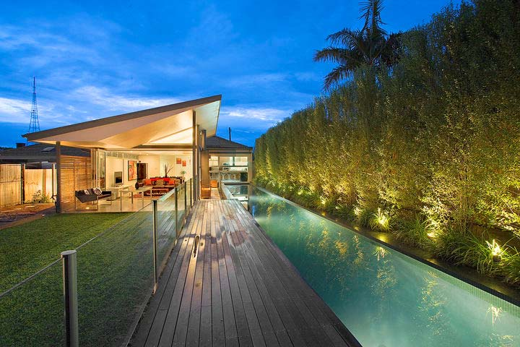
Week 1
Activity Report
124 Smith Street

For: Mr / Mrs Smith
Prepared By: Agent Name
Statistics:

Current Advertised Price: | $1,235,000 | Days On Market: | 12
Enquiries This Week: | 14 | Number of Open Homes: | 3
Total Enquiries: | 26 | Documents Requested: | 5
Open Home Attendees: | 50 | Offers Received: | 2
Total Open Home Attendees: | 67 | Offers Withdrawn: | 1

Open House Attendees Pricing Feedback:

Agents Commentary on Market Response:

Use this box to provide written feedback on marketing response and market feedback

Buyers Comments:

Positives |  | Comments:
Open Plan Living | Quality Fittings | The most common feedback from the market has been the quality of the kitchen and tranquillity of the pool garden area.
Kitchen | Pool / Garden Area
Second Living Area
North Facing

Negatives |  | Comments
Size of Bedrooms |  | As we expected the bedroom sizes and not having the lock up garage have had the most bearing on price
Floor coverings
Needs Painting
No Garage

Interested Parties:

Name | Feedback | # Inspe.

Withdrawn Interest:

Name | Feedback | # Inspe.

Agents Commentary on Buyer Activity:
Use this box to provide written feedback on buyer interest
Agents Summary:

Use this box to provide a complete summary of the week

Key Actions this Week:

• Monitor price guide
• Follow up current buyers and entice an offer prior to auction
• Consider upgrading to a premier listing on realestate.com
• Fix broken blind in 2nd bedroom
• Finalise 2nd payment for marketing

Moving Forward In Your Best Interests.

Kind Regards,
Agent Name
M: 0411 111 111
E: agent@changingplaces.com.au

