­

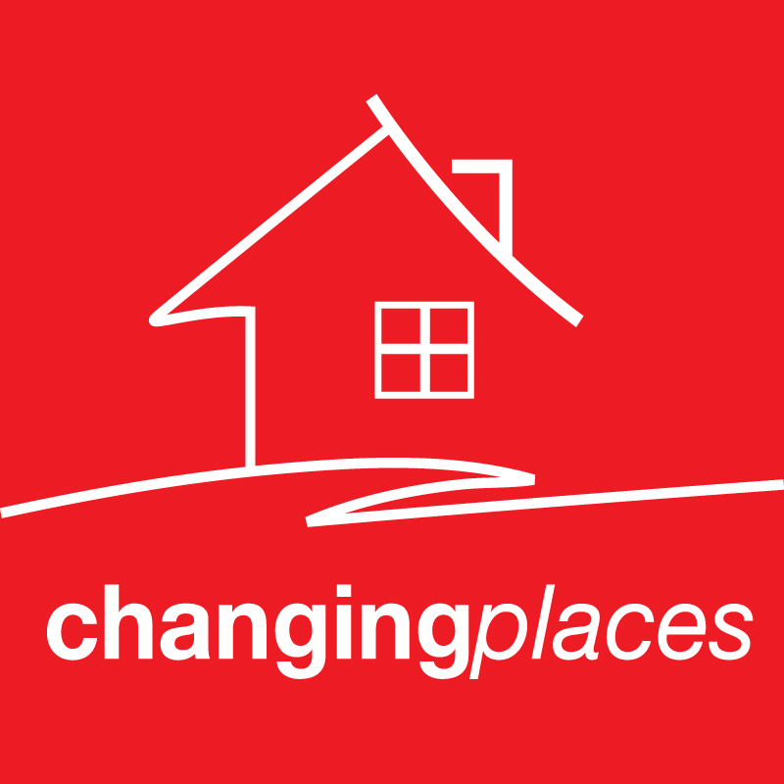

property appraisal & proposed Marketing strategy

*prepared for:*

*[client name]*

*Client*

Day Month Year

We Attract More Buyers

Our aim, working together with you, is to achieve the best possible outcome on the sale of your property. The most important aspect of your sale will be sourcing and securing the best buyer, we understand that buyers who live out the area will often pay a premium compared to local buyers and one of the benefits we can provide is our centralised database. This ensures we can tap into more buyers than traditional agencies who have a proprietary database in every office which doesn’t link with other agents under their brand. Our national network provides us with the access to a national database of qualified buyers which we are in constant communication with regarding their property needs, our first job as your agent will be to contact our buyer database and introduce your property to suitable buyers.

You Save on Commission

We believe the industry must accept a fundamental change in the way commission is charged. As leaders in our field, we introduced a “Fixed Fee” commission structure. This is calculated on the general demographic of the buyer and the level of effort and resources required to achieve the best possible outcome for your property. Our commission is not based on the dollar value of your home. It’s our unique business model that allows us to dramatically reduce overhead costs and we pass this saving on to you, saving you up to 65% on typical agent’s fees.

Benefit From a National Brand

You benefit from all the advantages of a national network buy receive the service you would expect from a boutique agency. The Changing Places agent you choose is dedicated to your property from day one and stays with you right throughout the sale process and beyond.

A Powerful Website

Today, most real estate business happens online and electronically. We provide a modern platform for buyers and sellers alike to obtain up-to-date information about the property market, industry trends and tips on buying and selling real estate. We embrace advances in technology to continually improve our services and efficiency

Marketing Excellence

We know how to attract the attention of buyers in a crowded market place. Our marketing plan isn’t designed to just find you a buyer - it’s designed to find every possible buyer for your property.

Because every home is unique, your marketing campaign needs to be specifically tailored to suit your property and your needs. To achieve maximum impact we design highly targeted campaigns using professional photographers, floor planners and printers. We have compiled a recommendation for what we believe to be the most effective combination of print media, websites, signboards, database marketing and brochures to showcase your property to perfection and to attract the maximum number of genuine buyers to your property.

Our Guarantee

As your agent, we are responsible for one of the largest financial transactions you will make in a lifetime. Should you appoint Changing Places to represent you and for any reason are not completely satisfied that we are doing what we have outlined, just give us a call. If we have not resolved the situation within 48 hours, we will terminate the listing / marketing agreement by written notice. Your satisfaction is our highest concern, we guarantee it.

Why Choose Us?



Address of Subject Property

Place Logo Or

Company Name Here

Address of Subject Property

Marketing Your Property

Essential Marketing Elements

**Photography**

Professional photographers will shoot an expansive selection of excellent quality digital photographs which are used for all our colour advertising and prints for distribution and to support editorial coverage in magazines and newspapers and online.

**Floor Plan**

This computer generated reproduction allows prospective buyers to accurately recall your property layout after an inspection. The plan will include room dimensions and will also be loaded onto your property listing when advertised on the internet.

**Property Brochures**

High quality double sided brochures are produced to showcase your property with stunning high resolution images and professionally written text to communicate the outstanding features and the opportunity your property presents. These brochures will be distributed at open for inspections and to interested buyers.

**Signboard**

The signboard is designed for maximum exposure with key information, with the property’s main selling benefits, and an interior colour photograph allowing the sign to stand out.

**Just Listed**

The invitations are designed to notify local buyers of your sale as well as use the local network to attract their friends, family and co-workers who may be looking to move to the area.

Digital Marketing Elements

The internet has undoubtedly become the most prolific property search tool with approximately 96% of buyers using it as their primary search tool.

**Changingplaces.com.au**

With a high level of website traffic visiting our company website each week, your property will be listed online in our for sale section When listed on our company site, your home will be automatically listed on the following websites

**Realestate.com.au**

Australia’s largest and most recognised real estate website we will list your property as a Highlight Listing for 30 days. This will provide 8x more exposure compared to a standard listing and attract more buyers to your property.

**Domain.com.au**

Australia’s second largest real estate web site and where you property will also be listed, we leave no stone unturned. We will also list your property as a Feature Listing ensuring that we attract the maximum amount of buyers to inspect your home.

**Open For Inspection**

We would recommend opening the property twice a week, on a Saturday and at another suitable day and time that is most appropriate for your property. Any appointment outside the open times would only be requested once the buyer has been fully qualified and with giving you 24 hours’ notice prior. Once open for inspection times have been confirmed they will then be displayed on the internet to attract potential buyers



Price Guide & Recommendations

$1,300,000 - $1,400,000

Based on comparable sales and the current market competition we believe your property should attract interest within the above price range.

Proposed Method of Sale

We believe that your property will have broad appeal in the marketplace and would therefore recommend a **Private Sale**. A low-key private sale approach gives your property the feeling of exclusivity, allowing for more one-on-one buyer inspections where we can truly identify the best buyer for your property.

Combining a high level of negotiation and ascertaining client feedback through the sale process we will achieve the absolute best available price from the market and we will also have greater control over the sale process by setting a fixed price or price guide to the advertised property. We then have the ability to work with buyers, truly understanding their needs. Ultimately with a private sale approach, there is no pressure to sell and you have much more flexibility.

3 Key Benefits

* Flexibility
* Time
* Control

Relevant Comparable Sales

|  |  |  |  |  |
| --- | --- | --- | --- | --- |
| Address: | 1 Smith Street, South Melbourne |  | Address: | 1 Smith Street, South Melbourne |
| Sale Price: | $1,250,000 |  | Sale Price: | $1,250,000 |
| Sale Date: | 7 July 2014 |  | Sale Date: | 7 July 2014 |
| Description: | (3) Bed (2) Bath (2) Car Garage |  | Description: | (3) Bed (2) Bath (2) Car Garage |

|  |  |  |  |  |
| --- | --- | --- | --- | --- |
| Address: | 1 Smith Street, South Melbourne |  | Address: | 1 Smith Street, South Melbourne |
| Sale Price: | $1,250,000 |  | Sale Price: | $1,250,000 |
| Sale Date: | 7 July 2014 |  | Sale Date: | 7 July 2014 |
| Description: | (3) Bed (2) Bath (2) Car Garage |  | Description: | (3) Bed (2) Bath (2) Car Garage |

Address of Subject Property



Place Logo Or

Company Name Here

Agency & Fees

Our fee for professional service is _______ plus GST based on the anticipated sale price of your property and the demographic of buyer we are likely to secure, alternatively we can prepare a sliding scale fee structure if you prefer.

We have also prepared a marketing schedule built around the elements we believe your property would require to achieve a premium result in today’s market, the total cost of our recommended marketing strategy is __________ including GST you can find the itemized schedule attached to this document and please note that all marketing costs are passed on to you at cost price.

In Summary

For us to proceed to a sale, we would recommend the following procedure:

* Finalise our appointment as exclusive agents for your home
* Approve and sign the marketing plan and Agency Agreement
* Contact your solicitor / conveyancer to prepare an agreement for sale

Please allow us to demonstrate to you our capabilities in marketing, negotiating and selling your property. We will manage the entire event with diligence, care, and understanding of your needs.



Thank you again for the opportunity to provide our recommendations to you.

Your Name Here

Your Title Here

Street Address

City, State 55555

www.webaddress.com

E: email@address.com

P: 555-555-5555

M: 555-555-5555

F: 555-555-5555